Day 3: Task 1
Please complete Get data in Power BI on Skillable. Once complete, paste a print screen below and in the collaboration board.

- Visit https://leeptalent.learnondemand.net/
- Sing into your profile
- Go to PL-300T00-A Design and Manage Analytics Solutions Using Power BI
- Launch and complete Lab 1: Get data in Power BI

Paste your completed lab here | 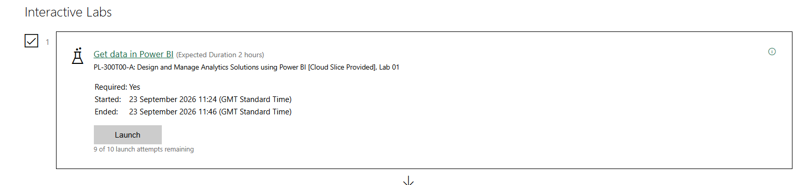

Day 3: Task 2
Please complete PL-300T00-A-Lab-02-LA] Clean, transform, and load data in Power BI on Skillable. Once complete, paste a print screen below and in the collaboration board.

- Visit https://leeptalent.learnondemand.net/
- Sing into your profile
- Go to PL-300T00-A Design and Manage Analytics Solutions Using Power BI
- Launch and complete Lab 2: Clean, transform, and load data in Power BI

Paste your completed lab here | 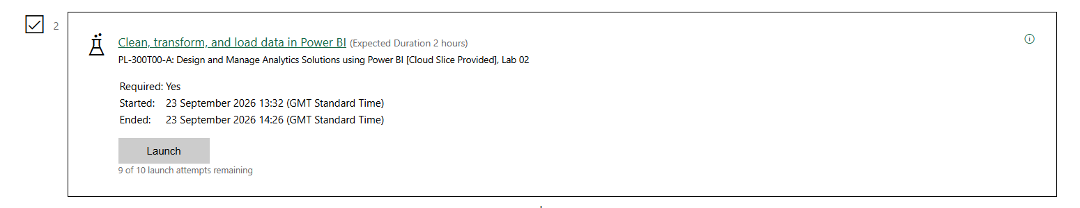

Day 3: Task 3 (Optional)

Explore Power BI course on DataCamp if you finish Day 3 Task 2 early. Introduction to Power BI

Paste your completed XP here

Day 4: Task 1
Please complete Design Power BI reports on Skillable. Once complete, paste a print screen below and in the collaboration board.

- Visit https://leeptalent.learnondemand.net/
- Sing into your profile
- Go to PL-300T00-A Design and Manage Analytics Solutions Using Power BI
- Launch and complete Lab 8: Design Power BI reports.

Paste your completed lab here | 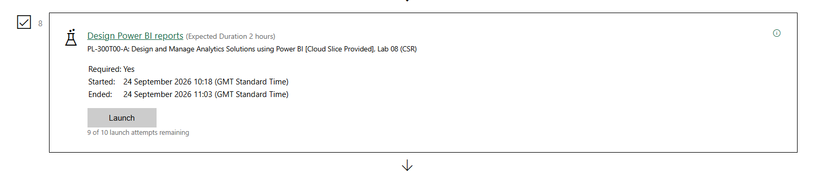

Day 4: Task 2

Please complete Create DAX calculations in semantic models on Skillable. Once complete, paste a print screen below and in the collaboration board.

- Visit https://leeptalent.learnondemand.net/
- Sing into your profile
- Go to PL-300T00-A Design and Manage Analytics Solutions Using Power BI
- Launch and complete Lab 4: Create DAX calculations in semantic models.

Paste your completed lab here | 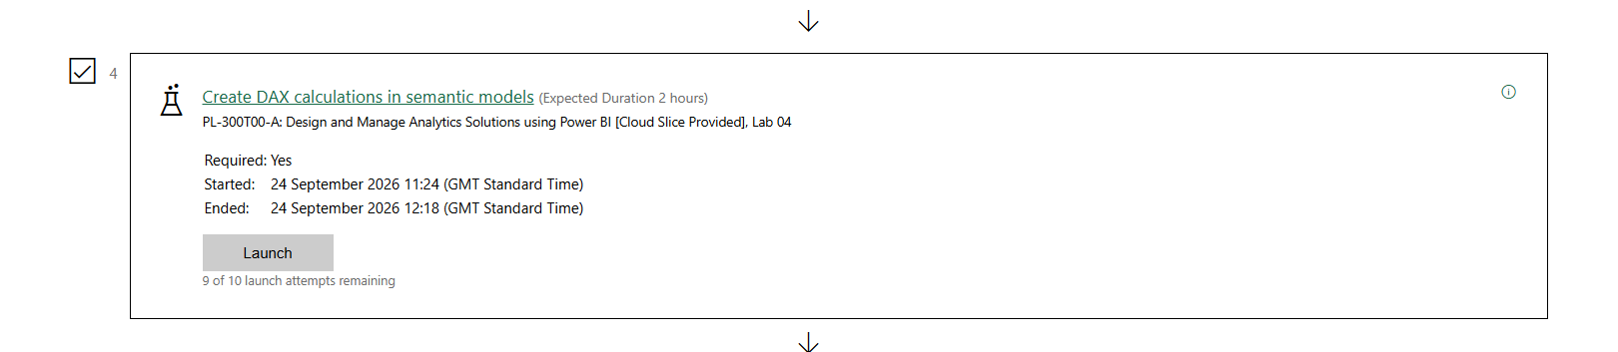

Day 4: Task 3

Please complete Configure a semantic model in Power BI. on Skillable. Once complete, paste a print screen below and in the collaboration board.

- Visit https://leeptalent.learnondemand.net/
- Sing into your profile
- Go to Lab PL-300T00-A Design and Manage Analytics Solutions Using Power BI
- Launch and complete Lab 3: Configure a semantic model in Power BI.

Paste your completed lab here | 